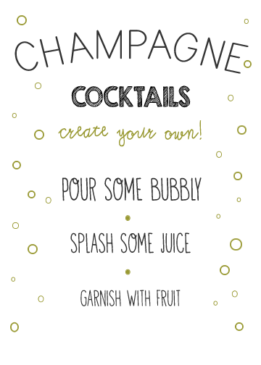

GARNISH **with** FRUIT

SPLASH SOME JUICE

POUR SOME BUBBLY

**COCKTAILS**